|  |  |  |
| --- | --- | --- |
| THEODORE ROOSEVELT ELEMENTARY SCHOOL  BINGHAMTON - SCHOOL |  |  |
|  |  |  |
| School Detail :- USD 383 has a rich history built upon the efforts of many individuals who firmly believed in the importance of public education to this community. We are proud of the tremendous breadth and depth of success attained by past and current students, and embrace expectations for continued success that are engrained in staff, parents, students, and the community-at-large.  USD 383 has a rich history built upon the efforts of many individuals who firmly believed in the importance of public education to this community. We are proud of the tremendous breadth and depth of success attained by past and current students, and embrace expectations for continued success that are engrained in staff, parents, students, and the community-at-large |  |  |
|  |

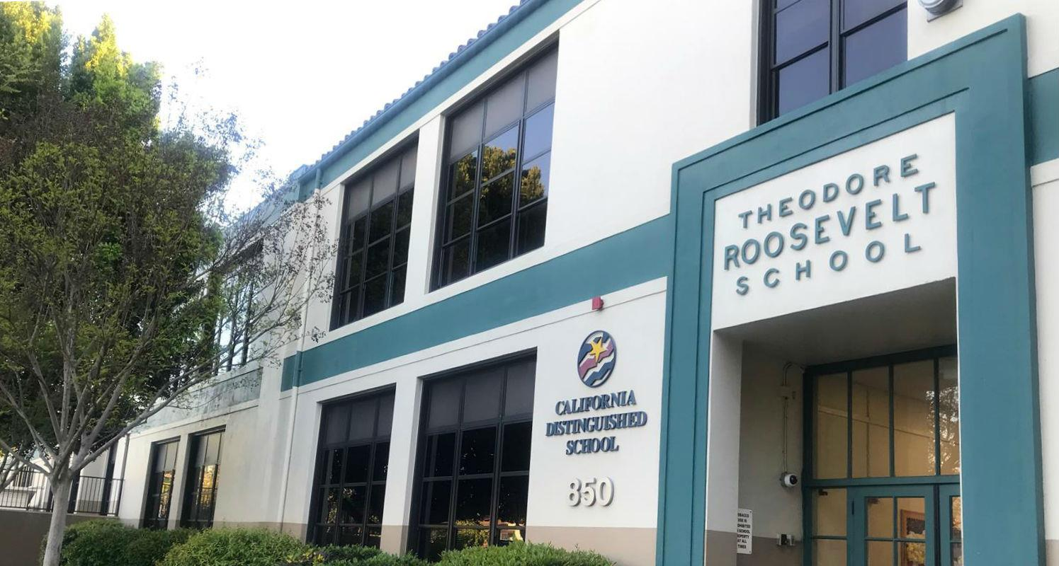

MINIMUM CAPACITY :-

The Minumum intake capacity

of students is between 1800-2000

children

LIBRARY :-

The Libarary is Available.

CANTEEN:-

The Canteen Facility is Available.

BOARDING :-

No availablility of boarding.

SPORTS :-

There are different categories

sports available.

Girls Volleyball

Boys Volleyball

Football